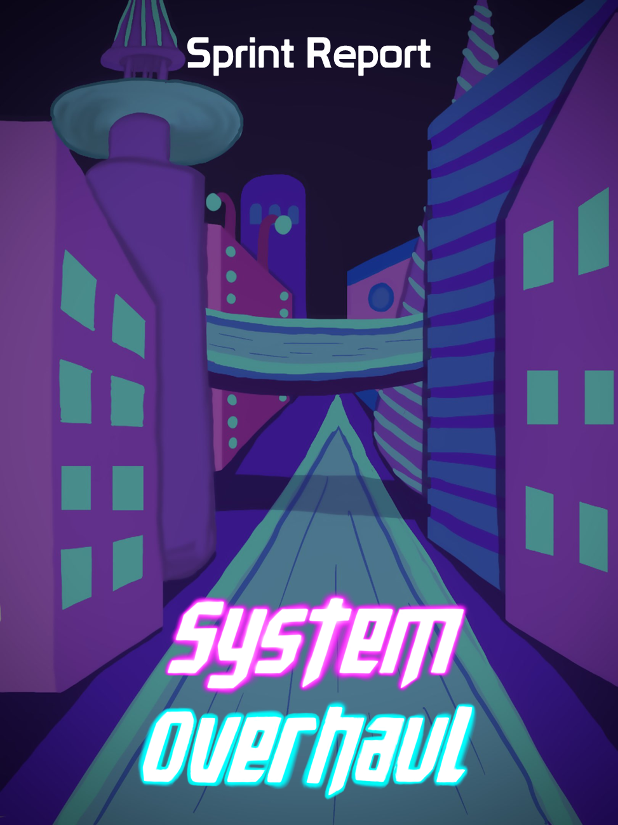





**Table of Contents**

**Previous Week** **2**

Sprint Backlog 2

Review 2

**Next Week** **3**

Sprint Backlog 3

Notes 3

# Previous Week

## Sprint Backlog

| **Tasks** | **Time Needed** | **Responsible** | **Priority** | **Stage** |
| --- | --- | --- | --- | --- |
| Find Sounds | 2 Days | All | Normal | In Progress |
| Improve Ranged Enemy | 2 Days | Sofia | High | Completed |
| Improve Melee Enemy | 2 Days | Gonçalo | High | Completed |
| Implement Sounds | 1 Day | All | Normal | In Progress |
| Main Menu | ½ Day | All | Normal | Completed |

* 1. Objectives

Most of our objectives were completed successfully.

The tasks of finding sounds and implementing sounds are overplanned.

No tasks were planned from the design part.

## Review

Most of the tasks were done successfully and were finished in time, the ones that weren’t finished were overplanned.

# Next Week

In the “Required for CG & AI” backlog our tasks with higher priority are the following:

| **Tasks** | **Time Estimate** |
| --- | --- |
| Improve the NPCs | 2 Days |

In the “Coding” backlog our tasks with higher priority are the following:

| **Tasks** | **Time Estimate** |
| --- | --- |
| Implement Sounds | 1 Day |
| Pause Menu | ½ Day |
| Controls Menu | ½ Day |
| Options Menu | ½ Day |
| Game Over Menu | ½ Day |
| Create City | 2 Days |
| Implement Shadows | ½ Day |
| Combine Code | ½ Day |

In the “3D Models & Animations” backlog the priority of the tasks didn’t change

In the “Docs” backlog our tasks with higher priority are the following:

| **Tasks** | **Time Estimate** |
| --- | --- |
| GDD - 3rd Delivery | 3 Days |
| Presentation Slides - 3rd Delivery | 1 Day |
| Delivery Report - 3rd Delivery | ½ Day |
| Instructions - 3rd Delivery | ½ Day |
| Spec Sheet - 3rd Delivery | 1 Day |
| Trailer - 3rd Delivery | 1 Day |

In the “UI / 2D / Sounds” backlog the priority of the tasks didn’t change

| **Tasks** | **Time Estimate** |
| --- | --- |
| Find Sounds | 1 1⁄2 Days |
| Creation of Stylized Abilities Icons | ½ Day |
| Creation of Stylized Buttons | 1⁄2 Day |
| Creation of Menu Background | 1⁄2 Day |
| Creation of Stylized Heath Bar | ½ Day |

## Sprint Backlog

| **Tasks** | **Time**  **Estimate** | **Responsible** | **Priority** | **Stage** |
| --- | --- | --- | --- | --- |
| Find Sounds | 2 Days | All | High | In Progress |
| Implement Sounds | 1 Day | All | High | In Progress |
| Improve the NPCs | 2 Days | All | High | Open |
| Game Over Menu | ½ Day | All | High | Open |
| Pause Menu | ½ Day | All | High | Open |
| Controls Menu | ½ Day | All | High | Open |
| Options Menu | ½ Day | All | High | Open |
| Implement Shadows | ½ Day | All | High | Open |
| Combine Code | ½ Day | All | Urgent | Open |

## Notes

As we are lacking communication with the designers we aren’t able to know what tasks they are giving priority.